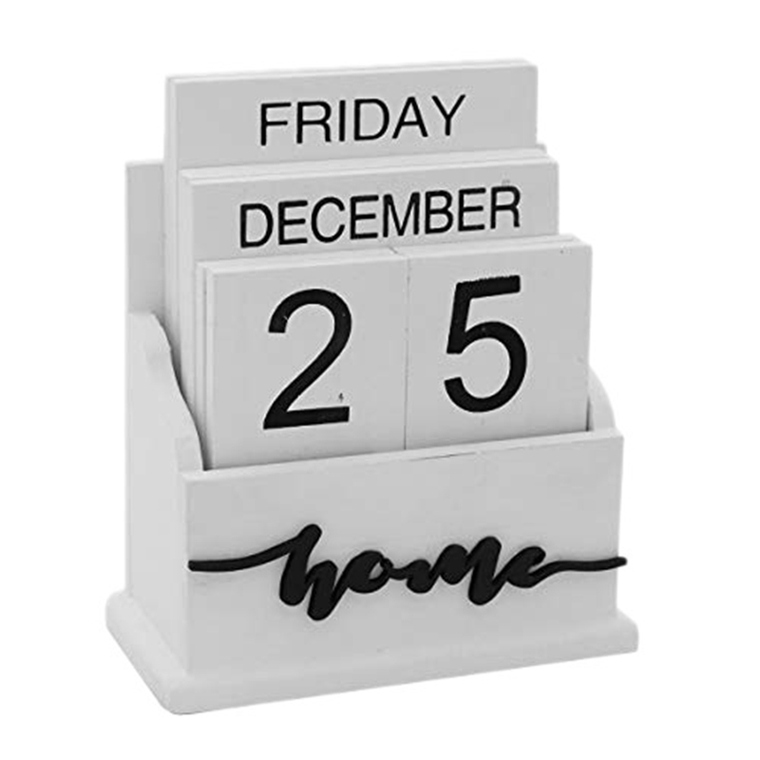

**STYLISH WOODEN CALENDAR**

RYANA CALENDARS is selling wonderful CALENDARS! at reasonable prices. It has perfect designs and color combinations.

**RS 880**